# Create Service Targets Procedure

Service Level Management

**Purpose**

A Service Target is used to measure specific service goals. Depending on their type, Service Targets can include costs, terms and conditions, measurements, and milestones with actions for a service goal. Service Targets can be related to SLAs, OLAs, or UCs, or they can be standalone and unassociated with any service or agreement. A Service Target can exist for a single service or multiple services.

**Related Policy**

* [IT Service Management Policy](https://sharepoint.jackson.com/sites/itsmsd/servicelevelmanagement/Shared%20Documents/Pre%20December%202019/SLM%20Documents/Policy%2C%20Process%2C%20Procedures/SLM_Service%20Level%20Management%20Process.doc?d=wa1eaba53e1dc4b30abda2a0886981cc9)

**Audience**

The following groups are responsible for adhering to this document:

* Service Level Management

**Procedure**

|  |  |
| --- | --- |
| Step | Action |
| 1 | Identify the Service Tier (Platinum, Gold, Silver, or Bronze), and each compliance Service Target percentage(s). This information will be used when naming the Service Target in Step 4 of this procedure:   1. Review the Metric Data Definition (MDD) to identify the Service Tier.  * Service Information   + Service Tier  1. Review the Metric Data Definition (MDD) to identify the Business Unit(s) and compliance Service Target percentage(s).  * Requirements section   + Business Unit   + Percentage |
| 2 | To access Service Level Management in Remedy to verify if a viable Service Target already exists, follow the instructions below:   1. In the Remedy system, select the Applications tab on the side. 2. Select “Service Level Management” 3. Select “Service Level Management Console”      1. On the “SLM Console” tab, click the “Folders” drop down-arrow. 2. Click “Standard Services” drop down-arrow. 3. Click “Monitored”      1. Click on the “Service Targets” tab   This will show existing Service Targets that have been created.  See **Appendix A** for the standard naming convention.     1. To put the Service Targets in alphabetical order, click “Title” on the blue bar.      1. If you need to review an existing Service Target, highlight the specific Service Target name in the list. 2. Click the “View” button.      1. If a viable Service Target already exists that matches the criteria found in the Metric Data Definition for the specified service, you are done with this procedure. 2. If the desired Service Target does not exist, continue to Step 3. |
| 3 | **To Create a Service Target**   1. Click the “Create” button.     “Step 1 of 4” will appear on the screen after clicking the “Create” button. There are four steps to complete.   * + Step 1 – General information   + Step 2 – Goals, costs, and business schedules   + Step 3 – Measurement criteria   + Step 4 – Milestones and actions  1. Continue to Step 4 to set up “Step 1 of 4”.   ***Note:*** *If multiple Business Units report on the same service, a Service Target must be created for each Business Unit.* |
| 4 | **SERVICE TARGET (STEP 1 of 4)**   1. Select the “Advanced” option.   This will auto-populate the “Agreement Type”, “Status”, and “Effective From” fields.   1. Update the “Effective From” field.  * Date – The first of the month in which you want to start using the Service   Target.   * Time – 12:00:00 AM   ***Note:*** *This sets the “SLA Time Scheduled” field on the Event Schedule form.*  For more information see:  [Event Schedule Form Documentation](../Documentation/Event%20Schedule%20Form%20Documentation.docx)     1. Enter information in the following fields:  * **Title:** Name the Service Target.   See ***Appendix A*** for the standard naming  convention.   * **Description:** Enter the business service name. * **Applies To**: Select “CI Unavailability” from drop down list. * **Goal Type**: Select “CI Outage” from drop down list. * **Related CI’s**: To set the Configuration Item, follow d) through l) below.      1. Click the “Define” button to relate an existing Business Service.      1. Click the “Relate” button      1. Perform a search in the “CI Name” field.      1. Click the “Search” button.      1. Select the correct Business Service name that ends with the “Tech Service”.      1. At the bottom of the screen, enter the same date that was used in the “Effective From” field (Step 4 b)) in the “Start Tracking From” field. The start date and time should always be the first of the month and be 12:00:00 AM (this allows a new   measurement record to be created at the start of each new month).  ***Note:*** *This sets the “OverallStartTime” field on the Measurement Record.*  For more information see:  [Measurement Record Documentation](../Documentation/Measurement%20Record%20Documentation.docx)   1. Select the Business Entity from the drop-down menu.      1. Click the “Relate” button      1. Ensure that the correct Business Service name, Business Entity, and Start Time appear.   ***Note:*** *On the first of each month at 12:00:00 AM when a new Measurement Record is created, the “Start Time” will update to match the current month’s “OverallStartTime” field of the Measurement Record.*     1. Click the “Close” button 2. Click the “Next” button. |
| 5 | **Goals & Costs (STEP 2 of 4)**  At this time no information needs to be added on this screen.   1. Click the “Next” button. |
| 6 | **Measurement Criteria (STEP 3 of 4)**   1. Type the following information in the “Outage Condition” field:   'Unavailability Type' = "Unscheduled Full" OR 'Unavailability Type' = "Unscheduled Partial"  ***Note:*** *This information is used to invoke a CI Unavailability record when an Incident ticket is created for a service outage.*     1. The “Description” is left blank. 2. Lifecycle Interval is “1” Month      1. Click the “Next” button. |
| 7 | **Milestones (STEP 4 of 4)**  Milestones can use Milestone templates or be customized. To use Milestone templates, follow a) through f) below or to create a customized Milestone, follow g) through l) below:   1. Click the “Add” button under the “Milestones” box.      1. Click the down-arrow at the “Select” field. 2. Select “Template”.      1. A list of Milestone templates will appear. Find the Milestone you are looking for and click it.     For more information see:  [Create a Milestone Action Template Procedure](Create%20a%20Milestone%20Template%20Procedure.docx)   1. Click the “OK” button. 2. Repeat a) through e) until all requested Milestones have been added.      1. To create a customized Milestone, click the “Add” button.      1. Click the down-arrow at the “Select” field. 2. Select “Custom”. 3. Select “New Milestone” 4. Click the “OK” button.      1. See Step 3 e) through h) of the [Create a Milestone Template Procedure](Create%20a%20Milestone%20Template%20Procedure.docx) to complete the customized milestone.   On the same screen, corresponding Actions will need to be linked to each Milestone.  To use Milestone Action templates follow m) through t) below or to create a customized Milestone Action, follow u) through z) below:   1. In the Milestone box click on the appropriate Milestone in which an Action is to be linked. 2. Click the “Add” button under the “Actions” box.      1. Select the down-arrow. 2. Select “Template” 3. A list of Action templates will appear. Find the Action you are looking for and click it.     For more information see:  [Create a Milestone Action Template Procedure](Create%20a%20Milestone%20Action%20Template%20Procedure.docx)   1. Ensure that the percentage in the template matches the Milestone to which it is   being linked to. (example; a 50% Milestone of 98% Service Target needs to have  a 50% of 98% Milestone Action).   1. Repeat m) through r) until the corresponding Milestone Actions have been linked to each Milestone. 2. Verify that each Milestone percentage matches the Milestone Action percentage by clicking on the Milestones one at a time.      1. To create a customized Milestone Action, click the “Add” button.      1. Click the down-arrow at the “Select” field. 2. Select “Custom”. 3. Select “New Alert or Email Action”.   ***Note:*** *At this time “New Alert or Email” are the only actions being performed.*   1. Click the “OK” button.      1. See Step 3 e) through f) of the [Create Milestone Action Template Procedure](Create%20a%20Milestone%20Action%20Template%20Procedure.docx) to complete the customized milestone. |
| 8 | Once all four Steps have been completed it is time to build the Service Target.   1. Click the “Finish” button.      1. Click the “Yes” button.      1. This will return you to the main Service Level Management screen.   Follow Steps 2 e) through 2 i) to locate the required Service Target that has just been created.   1. “Built Successfully” or “Build in Progress” are expected. If the status is “Build in Progress”, click the “Refresh” button until the status updates to “Built Successfully”. 2. Once the status of “Built Successfully” appears, verify that a Measurement Record has been created and that the “OverallStartTime” field matches the “Start Time” that was used when relating a CI to the Service Target. It should be 12:00:00 AM of the current month.   For more information see:  [Measurement Record Documentation](../Documentation/Measurement%20Record%20Documentation.docx)   1. Verify the “SLA Time Scheduled” field on the Event Scheduled form for the Service Target that was just created. It should be 12:00:00 AM on the first date of the following month. This states when a new Measurement Record will be created.   For more information see:  [Event Schedule Form Documentation](../Documentation/Event%20Schedule%20Form%20Documentation.docx)   1. After the Service Target has been created, the Measurement Record, and Event Schedule Form have been verified, an Agreement and a Master Record will need to be created.   For more information se:  [Create an Agreement Procedure](Create%20an%20Agreement%20Procedure.docx)  [Create a Master Record Procedure](Create%20a%20Master%20Record%20Procedure.docx)   1. Locate the Service Target that has just been created.      1. If “Could Not Be Built” or “Needs to Be Built” appears, highlight the Service Target and click the “Build” button.      1. Click the “Yes” button.      1. Click the “Refresh” button until the status changes from “Build in Progress” to “Built Successfully”. 2. If the status returns to “Could Not Be Built”, see ***Appendix B.*** |

**Appendix A – Service Target Standard Naming Convention**

The Service Target name should follow this format:

***SVT-CIU-AAA-BBB-CC***

***AAAA*** = Business Unit

Use these abbreviations for the Business Unit.

* Actuarial – ACT
* Broker Dealer – BD
* Finance – FIN
* Jackson Enterprise Technology - JET
* JNL Asset Management – JNAM
* Operations – OPS

***BBBB*** – Service Name

Use the service name that is used in the “Service*+” field of an incident ticket.



***Note:*** *If a service name contains any text in parenthesis, do not include the parenthesis in the Service Target name. If the title contains parenthesis use a hyphen between the service name and the acronym.*

**

***Example:*** *Cash Disbursement System (CDS) should be:*

*SVT-CIU-OPS-Cash Disbursement System-CDS-99*

**CC**= Compliance target percentage.

***Example***: SVT-CIU-Cash Disbursement System-CDS-99

***Note:*** *The compliance target percentage number is needed in the title as it is used to auto-populate the “Compliance Target” field when the Master Record is created.*

For more information see:

[Create a Master Record Procedure](Create%20a%20Master%20Record%20Procedure.docx)

**Appendix B – Service Target “Could Not Be Built” status.**

In the event that a Service Target has a status of “Could Not Be Built”, verify the following:

* The Service Target name does not include parenthesis in the title.
* Compare the Data Sources between Production and Development to ensure there are no differences.

1. In both Production and Development Remedy, select the Applications tab on the side.
2. Select “Administrator Console”.
3. Select “Application Administration Console”
4. Click the “Custom Configuration” tab
5. Click “Service Level Management”

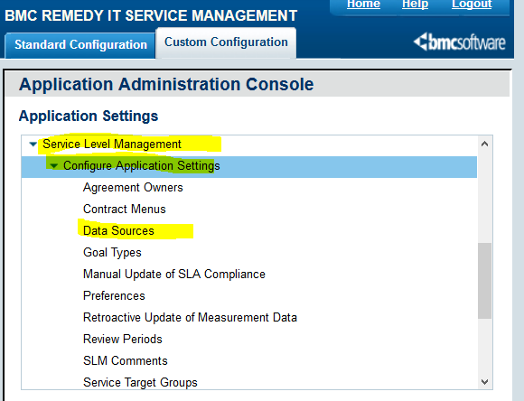

1. Click “Data Sources”. A list will appear.

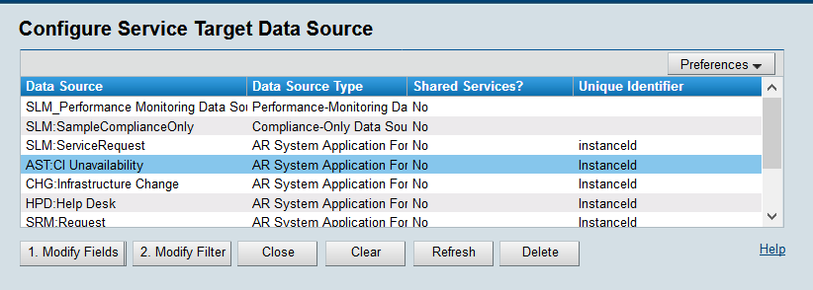

1. Click on “AST: CI Unavailability”. Information will appear at the bottom of the screen. Ensure that the following fields match between Production and Development.

* Data Source / App Form
* Data Source Display As
* Field as Unique Identifier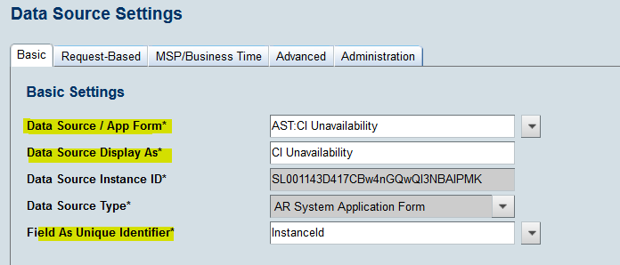
* If these do not match, create an Incident ticket for ITSM Suite Administration to

investigate which one is correct. Ensure to enter the Service Target name and all

relevant details.

* If these do match up, then delete the Service Target that has been created and rebuild

It.

***Note***: *Once the Data Sources are set, they should not have to be updated again*.

**Modification**

The following associates can make modifications to this document:

* Manager, Service Level Management
* Director, IT Service Management
* Vice President, Service Delivery
* Chief Technology Officer, PGDS

|  |  |
| --- | --- |
| Service Level Management Process | |
| Responsible Party: Anna Carter, Manager, Service Level Management Approving Authority: Abdul Golden, Director, IT Service Management | Date Created: 08/23/2017 Last Modified:  Last Reviewed: |